### PDCA stands for Plan, Do, Check, Act.

**White** **box**

**White** **box** testing which also known as glass box is **testing, structural testing, clear box testing, open box testing and transparent box testing**.

* Data Flow Testing
* Control Flow Testing
* **Statement** Coverage Testing
* **Decision** Coverage Testing
* **Branch** Coverage Testing
* Toggle Coverage
* FSM Coverage

## **White Box Testing Techniques:**

**Statement Coverage**:- This technique requires every possible statement in the code to be tested at least once during the testing process of software engineering.

**Branch Coverage -**This technique checks every possible path (if-else and other conditional loops) of a software application.

## **White Box Testing Tools**

Below is a list of top white box testing tools.

* [Parasoft Jtest](http://bit.ly/2V8ypxo)
* [EclEmma](http://www.eclemma.org/download.html)
* [NUnit](http://nunit.org/)
* [PyUnit](https://www.guru99.com/python-unit-testing-guide.html)
* [HTMLUnit](http://htmlunit.sourceforge.net/)
* [CppUnit](https://sourceforge.net/projects/cppunit/)

**Black** **Box**

**Black** **Box** Testing is also known as **functional testing, data-driven testing, and closed box testing.**

**Error guessing** is a technique in which there is no specific method for identifying the error. It is a type of **black box testing technique**

## **Types of Black Box Testing**

There are many types of Black Box Testing but the following are the prominent ones -

* **Functional testing** - This black box testing type is related to the functional requirements of a system; it is done by software testers.
* **Non-functional testing**- This type of black box testing is not related to testing of specific functionality, but non-functional requirements such as performance, scalability, usability.
* **Regression testing**- [Regression Testing](https://www.guru99.com/regression-testing.html) is done after code fixes, upgrades or any other system maintenance to check the new code has not affected the existing code.
* For Functional/ Regression Tests you can use - [QTP](https://www.guru99.com/quick-test-professional-qtp-tutorial.html), [Selenium](https://www.guru99.com/selenium-tutorial.html)
* For Non-Functional Tests, you can use - [LoadRunner](https://www.guru99.com/loadrunner-v12-tutorials.html), [Jmeter](https://www.guru99.com/jmeter-tutorials.html)

# **System Testing**

Regression Testing

Regression testing is performed under system testing to confirm and identify that if there's any defect in the system due to modification in any other part of the system.

### Load Testing

Load testing is performed under system testing to clarify whether the system can work under real-time loads or not.

### Functional Testing

Functional testing of a system is performed to find if there's any missing function in the system.

### Migration Testing

Migration testing is performed to ensure that if the system needs to be modified in new infrastructure so it should be modified without any issue.

### Usability Testing

The purpose of this testing to make sure that the system is well familiar with the user and it meets its objective for what it supposed to do.

## **Black Box Testing Techniques**

Following are the prominent[Test Strategy](https://www.guru99.com/how-to-create-test-strategy-document.html)amongst the many used in Black box Testing

* **Equivalence Class Testing:** It is used to minimize the number of possible test cases to an optimum level while maintains reasonable test coverage.
* **Boundary Value Testing:** Boundary value testing is focused on the values at boundaries. This technique determines whether a certain range of values are acceptable by the system or not. It is very useful in reducing the number of test cases. It is most suitable for the systems where an input is within certain ranges.
* **Decision Table Testing**: A decision table puts causes and their effects in a matrix. There is a unique combination in each column.

Grey Box Testing is also known as translucent testing as the tester has limited knowledge of coding. A combination of Black Box and White Box testing methodologies:

|  |  |  |  |  |  |
| --- | --- | --- | --- | --- | --- |
| **S.No.** | | **Smoke Testing** | | **Sanity Testing** | |
| 1 | It is a broad approach to testing where all parts of the application are tested.  **Smoke testing is done to assure that the acute functionalities of program is working fine.** | | It is a narrow approach to testing where specific parts of the application are tested.  **Sanity testing is done to check the bugs have been fixed after the build** | |

In short, the difference between beta testing and alpha testing is the location where the tests are done.

|  |  |  |  |  |
| --- | --- | --- | --- | --- |
| **No. Alpha Testing** | | |  | **Beta Testing** |
| **1.** | Alpha testing performed by a team of highly skilled testers who are usually the internal employee of the organization. | Beta testing performed by clients or end-users in a real-time environment, who is not an employee of the organization. | | |
| **2.** | **Alpha testing performed at the developer's site;** | **it is performed at a client's location or end-user of the product.** | | |
| **3.** |  |  | | |
| **4.** | Alpha testing involves both white box and black-box techniques. | Beta testing uses only black-box testing. | | |

There are three types of defects: Wrong, missing, and extra.

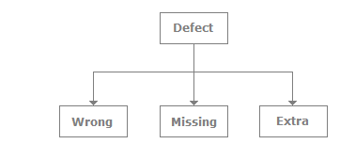

. **Which is the best testing model?** **Tailored models** are most productive and beneficial for many organizations. If it's a pure testing project, then the **V model** is the best.

**Defect and a failure**

When a defect reaches the end customer it is called a failure and if the defect is detected internally and resolved it's called a defect.

It's a recorded fact that if a defect is delayed for later phases it proves more costly.

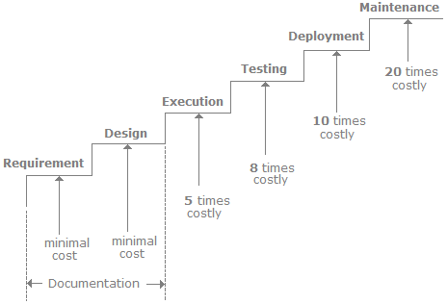

**Workbench**

A Workbench is a way of documenting how a specific activity has to be performed. A workbench is referred to as phases, steps, and tasks as shown in the following figure.  
  
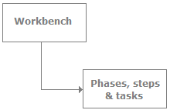

**Unit Testing**

In SDLC, STLC, V Model, Unit testing is first level of testing done before integration testing. Unit testing is a White Box testing technique that is usually performed by the developer.

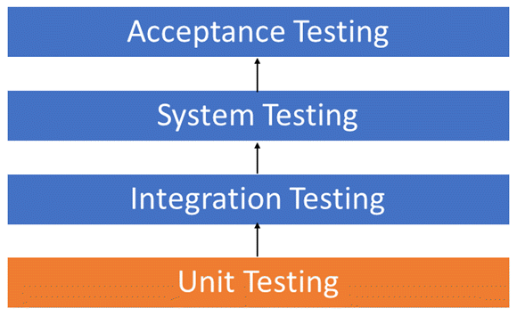

## Unit Testing Techniques

* Statement Coverage
* Decision Coverage
* Branch Coverage
* Condition Coverage
* Finite State Machine Coverage

**Integration Testing**

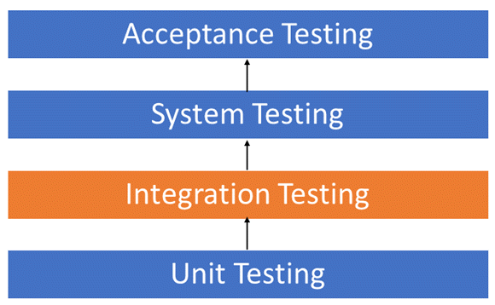

## Unit Testing Techniques

* Big Bang Approach : Here all component are integrated together at **once** and then tested.
* Incremental Approach: which is further divided into the following
  + Top Down Approach
  + Bottom Up Approach
  + Sandwich Approach - Combination of Top Down and Bottom Up

### System Testing

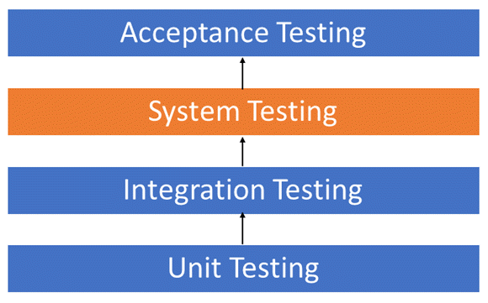

System test falls under the **black box testing** category of software testing.

System test involves the external workings of the software from the user's perspective.

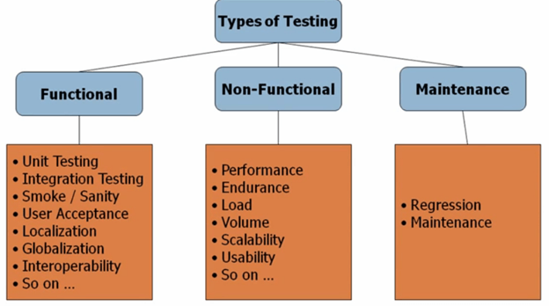

1.

<https://www.firstnaukri.com/career-guidance/latest-software-testing-multiple-choice-questions-mcqs-with-explanation>

2.

<https://www.sanfoundry.com/software-engineering-questions-answers-online-test/>

3.

<https://www.careerride.com/mcq-topics/software-testing-mcq-questions-and-answers-placement-tests-14.aspx>

4. Maven Vs Ant

<https://www.sanfoundry.com/advanced-java-questions-answers-application-lifecycle-ant-maven-jenkins/>